Yohanes Dimas Pratama

A11.2021.13254 - 442U

Data Mining

Tugas Pertemuan 7

1. Menghitung Entropy dan Gain serta menentukan Decision Tree dari kasus dibawah:

|  |  |  |  |  |
| --- | --- | --- | --- | --- |
| Outlook | Temperature | Humidity | Windy | Play |
| Sunny | Hot | High | No | Don't Play |
| Sunny | Hot | High | Yes | Don't Play |
| Cloudy | Hot | High | No | Play |
| Rainy | Mild | High | No | Play |
| Rainy | Cool | Normal | No | Play |
| Rainy | Cool | Normal | Yes | Play |
| Cloudy | Cool | Normal | Yes | Play |
| Sunny | Mild | High | No | Don't Play |
| Sunny | Cool | Normal | No | Play |
| Rainy | Mild | Normal | No | Play |
| Sunny | Mild | Normal | Yes | Play |
| Cloudy | Mild | High | Yes | Play |
| Cloudy | Hot | Normal | No | Play |
| Rainy | Mild | High | Yes | Don't Play |

|  |  |  |  |  |  |  |
| --- | --- | --- | --- | --- | --- | --- |
| Total | | Jumlah Kasus (S) | Don't Play (S1) | Play (S2) | Entropy | Gain |
| 14 | 4 | 10 | 0.8631 |  |
| Outlook | Sunny | 5 | 3 | 2 | 0.9709 | 0.2585 |
| Cloudy | 4 | 0 | 4 | 0 |
| Rainy | 5 | 1 | 4 | 0.7219 |
| Temperature | Hot | 4 | 2 | 2 | 1 | 0.1838 |
| Mild | 6 | 2 | 4 | 0.9182 |
| Cool | 4 | 0 | 4 | 0 |
| Himidty | High | 7 | 4 | 3 | 0.9852 | 0.3705 |
| Normal | 7 | 0 | 7 | 0 |
| Windy | No | 8 | 2 | 6 | 0.8112 | 0.006 |
| Yes | 6 | 2 | 4 | 0.9182 |

*Node 1

*Decision Tree Node 1

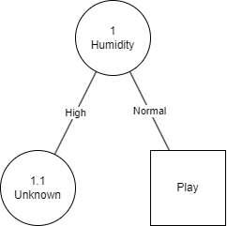

*Node 1.1

|  |  |  |  |  |  |  |
| --- | --- | --- | --- | --- | --- | --- |
|  | | Jumlah Kasus (S) | Don't Play (S1) | Play (S2) | Entropy | Gain |
| Humidity High |  | 7 | 4 | 3 | 0.9852 |  |
| Outlook | Sunny | 3 | 3 | 0 | 0 | 0.6994 |
| Cloudy | 2 | 0 | 2 | 0 |
| Rainy | 2 | 1 | 1 | 1 |
| Temperature | Hot | 3 | 2 | 1 | 0.9182 | 0.0202 |
| Mild | 4 | 2 | 2 | 1 |
| Cool | 0 | 0 | 0 | 0 |
| Windy | No | 4 | 2 | 2 | 1 | 0.0202 |
| Yes | 3 | 2 | 1 | 0.9182 |

*Decision Tree Node 1.1

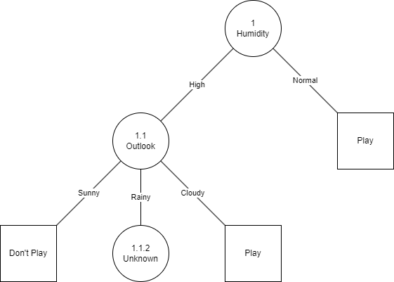

*Node 1.1.2

|  |  |  |  |  |  |  |
| --- | --- | --- | --- | --- | --- | --- |
|  | | Jumlah Kasus (S) | Don't Play (S1) | Play (S2) | Entropy | Gain |
| Humidity High |  | 2 | 1 | 1 | 1 |  |
| and Outlook Rainy |
| Temperature | Hot | 0 | 0 | 0 | 0 | 0 |
| Mild | 2 | 1 | 1 | 1 |
| Cool | 0 | 0 | 0 | 0 |
| Windy | No | 1 | 0 | 1 | 0 | 1 |
| Yes | 1 | 1 | 0 | 0 |

*Decision Tree 1.1.2

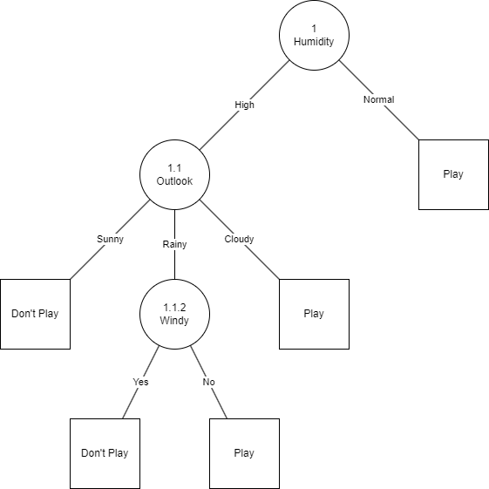

1. Link GitHub program python Decision Tree

<https://github.com/weztcy/Semester-4/blob/main/Data%20Mining/7%20-%20Klasifikasi%20dengan%20Decision%20Tree/Decision_Tree.ipynb>